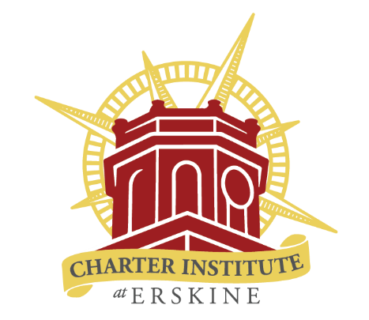

Office of Federal Programs

1201 Main Street, Suite 300, Columbia, SC 29201

Stipend Methodology Policies

The Charter Institute at Erskine Office of Federal Programs requires a written policy for all stipends. Schools must ensure applicable policies are approved by their School Board. The following must be included in each stipend policy to be approved:
- Funding Source
- Policy Title
- Eligibility
- Process
- Eligible Person(s)
- Awards and Recognition

Example Policy:
Funding Source: Title II
Title: ABC School Teacher Mentor Program Stipend
Eligibility: All teachers that fulfill the Institute requirements of Induction Teacher Mentoring for 2020-2021.
Process: To encourage recruitment and retention of highly qualified teachers in ABC School, the school will award monetary stipends to teachers that mentor induction year teachers.
Eligible Person(s): An eligible person is an instructional teacher. The employee must have worked at least through 05/01/21 of the current school year (FY 2020-2021) to be eligible. The employee must have completed all Institute and SCDE requirements related to the Induction Mentor Program. The requirements log will be printed and signed by the teacher to certify completion, as well as include supporting documentation of requirements in SC Lead which includes monthly mentor logs.
Awards and Recognition
6 teacher mentors will receive a $250 stipend on 05/25/21 and will be recognized at the 05/25/21 staff meeting.
Total Cost: 6 stipends at a cost of $250 each, for a total of $1,500 (Title II).

