

MODEL STUDENT ATTENDANCE INTERVENTION PLAN

student’s truancy, document the previous steps taken by the school to address the student’s
truancy problem, and develop the plans necessary to improve the student’s future attendance.

Student’s Name:

Student Attendance History

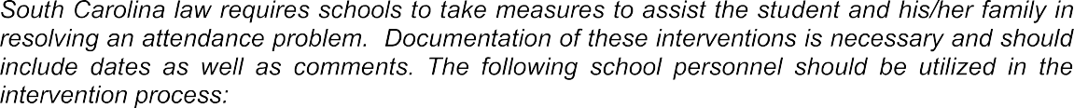

•

•

•

•

52

•

•

•

•

•

•

What is the nature of the student’s attendance problem?

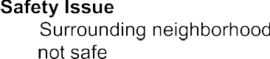
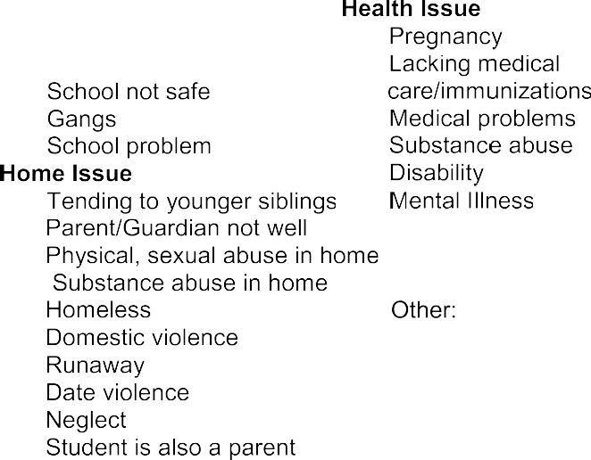
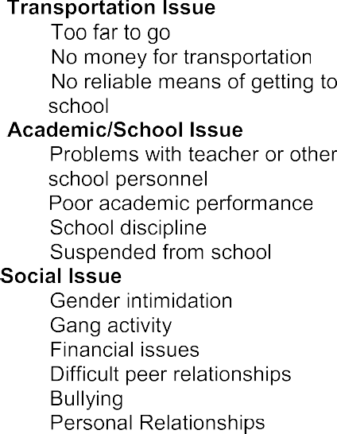

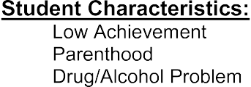





53

Student’s Signature Parent/Guardian’s Signature

School Official’s Signature Parent/Guardian’s Signature

“Guidelines for Improved Student Attendance and Truancy Prevention,” which was developed by Chicago Public Schools’ Office of Instruction and School Management.

54



STUDENT CONTRACT TO IMPROVE ATTENDANCE

C.
D.

D

D
We (student, parent/guardian and school) will meet again to review that student’s

“Guidelines for Improved Student Attendance and Truancy Prevention,” which was developed by Schools’ Office of Instruction and School Management.

